Drone Simulation Design Manual
Author: Jack Jiang (z5129432)
Date: 03/10/2017

This design manual describes how the emulating system is designed, includes:
- Data structures and algorithms used in the software design
- system control flow at the module level using a diagram, which shows interaction between modules and input/output operations.

Data structures:
The map of the mountain will be stored in program memory.

Modules:
This program can be divided into four modules, as follows:
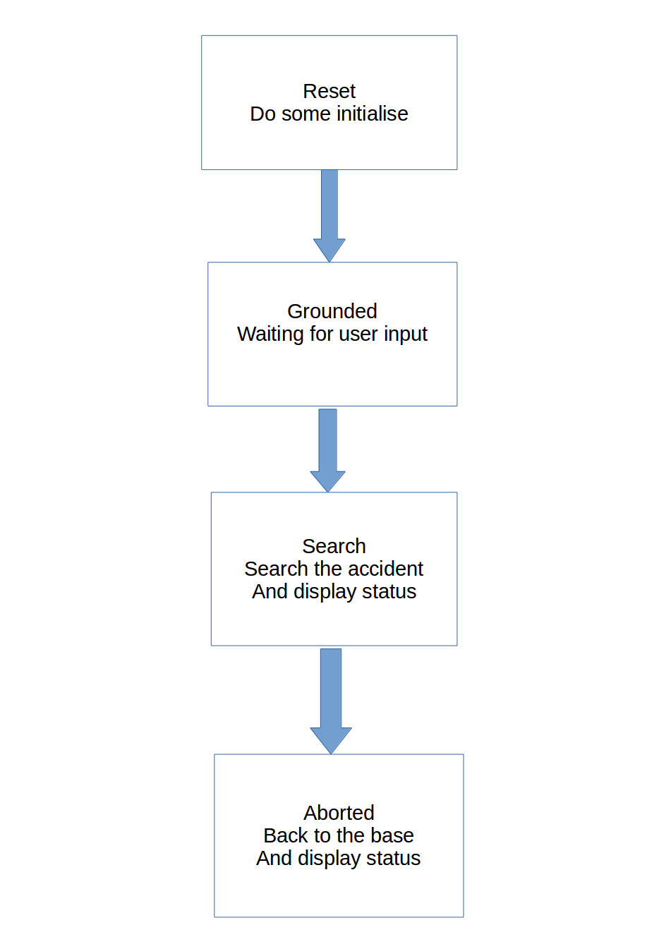

Reset
Do some initialisation functions

Grounded
Waiting for user input (accident) and check the validity of input. After # is pushed, go to next module.

Searching path
Y will increase 1 in x increased to 63 or decreased to 0
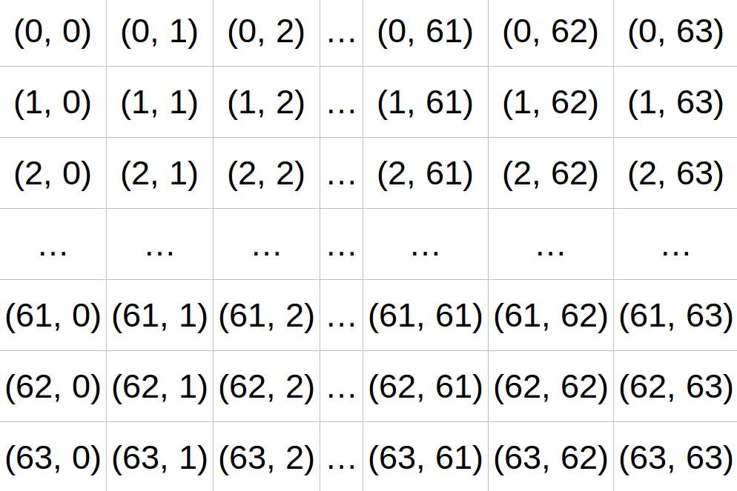

Aborted

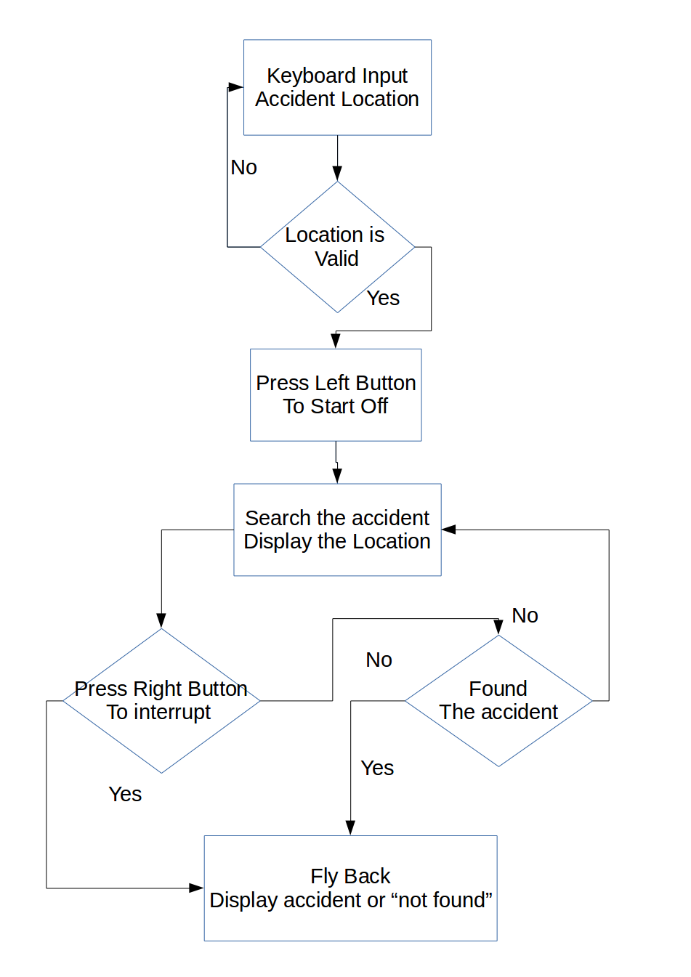
Flow chart:

